The 21st Summer Deaflympics－ CYCLING

Technical Guide



6 to 12 September, 2009

Taipei Organizing Committee of the 21st Summer Deaflympics
Chinese Taipei Cycling Association

Contents
1 | General Technical Rules – Summer Deaflympics
2 | Technical Regulations in English
3 | Technical Regulations in Chinese
4 | Notice for Rider
5 | Location
6 | Practice Schedule
7 | Competition Schedule
8 | Time Table of Competition
9 | Records
10 | Map
11 | Games Program Schedule
12 | Contact Information
- General Technical Rules – Summer Deaflympics
1. TIME AND DURATION
The 21st Summer Deaflympics will take place from 2 September to 15 September 2009 in Taipei, Chinese Taipei.
2. PROGRAM
The program of the 21st Summer Deaflympics includes the following disciplines:
2.1. Individual sports: Athletics, Badminton, Beach Volleyball, Bowling, Cycling Road, Judo, Karate, Orienteering, Shooting, Swimming, Table Tennis, Taekwondo, Tennis, Wrestling Freestyle & Wrestling Greco-Roman.
2.2 Team sports: Handball, Football, Handball, Volleyball & Water Polo.
2.3. The events of individual sports are specified in the Special Rules and Regulations for each sport.
2.4. Only those sports and events having received preliminary/final entry registrations from at least five (5) countries / two (2) regions for males and females shall remain on the official program.
2.5. In case of a cancellation of a sport or an event due to DG7 5, the Secretariat of the International Committee of Sports for the Deaf (ICSD) shall notify the affected National Associations at least fourteen (14) days after the deadline for preliminary registrations and, if necessary, immediately after the deadline for final registrations.
3. ELIGIBILITY
3.1. The Summer Deaflympics bring together, in a honest and impartial competition, Deaf athletes of all affiliated full members.
3.2. No discrimination is permitted toward an Association or a person on account of race, religion or political affiliations.
3.3. Participation in the Summer Deaflympics is restricted to persons who are:
1. Deaf, defined as a hearing loss of at least 55 dB in the better ear (3-tone frequency average at 500, 1000 and 2000 Hertz, ISO 1964 Standard),
2. Members of an affiliated National Association.
3.4. There is, as a rule, no age limit for competitors. There may, however, be age limits for a specific sport or event, per sport regulations.
3.5. The registration forms will include the text of the eligibility code to be signed by two officials (normally the president and secretary) of the Association: "We, the undersigned, declare that we have read the eligibility conditions for the Summer Deaflympics and that we and our athletes comply with them. We agree to be filmed or photographed during the Summer Deaflympics under the conditions and for the purposes authorized by the International Committee of Sports for the Deaf."
3.6. No entry shall be valid unless the above Rules shall have been observed.
3.7. All participants must hold the nationality of the country of their National Association. In case of objections, the Association concerned must provide proof of nationality, by providing a copy of passport.
4. CONTROL AND SANCTIONS
4.1. A list of athletes who have previously submitted an audiogram is distributed to each association. Athletes whose names appear on the list do not need to submit a new audiogram. All other athletes (whose names are not on the list) must, prior to participation, submit to Secretariat an audiogram on forms supplied by ICSD through website.
4.2. The athletes registered for the Summer Deaflympics may be required to take additional hearing tests during the Summer Deaflympics.
4.3. All athletes may be required to undergo doping tests.
4.4. An athlete who fails any of these above tests, he/she will be taken out of competition immediately. If he/she competes in different events in this sport, he/she will be disqualified only in the event the violation was done.
4.5. In the case where such an athlete is a member of a team he/she will be taken out of the game immediately. He/she will be disqualified for the rest of the game and the next game. A substitute for him/her may enter the competition.
4.6. In the case of fraud, the National Association will be obliged to pay all penalty expenses and fines imposed by the Executive Committee of ICSD.
4.7. All other expenses for tests taken during the Summer Deaflympics are to be borne by the Organizing Committee.
4.8. An athlete who use medicine or forbidden substances due to permanent illness (allergy, asthma, epilepsy) must submit a doctor's declaration which must be handed over to the Organising Committee at the registration immediately after arrival.
5. ENGAGEMENTS
5.1. Only affiliated National Associations are allowed to register competitors in the Summer Deaflympics.
5.2. The maximum number of engagements in each sport and event is specified in the Special Rules and Regulations for each sport.
5.3. For every three athletes entered the National Association is allowed to appoint one official plus one official for each sport (excluding delegates to the Congress).
5.4. The registration forms for the 21st Summer Deaflympics will be supplied by Secretariat.
6. TEAM SPORTS
6.1. The deadline for preliminary registration for team sports is 1 March 2007.
6.2. The deadline for final registration for team sports is 1 August 2008.
6.3. The fine for withdrawal between 2 August 2008 - 31 July 2009 is USD $2,500 to be paid immediately after the withdrawal.
6.4. The fine for withdrawal after 1 August 2009 is USD $5,000 to be paid immediately after the withdrawal.
7. INDIVIDUAL SPORTS
7.1. Preliminary registrations with an indication of the probable number of athletes in each sport and event must be submitted to the Secretariat no later than 1 August 2008.
7.2. The final registrations with the names of each athlete indicating sport and event entered must be submitted to the Secretariat no later than 1 August 2009. Such submissions will be made via official online registration form or telefax followed by the official registration form.
7.3. No additional entries will be accepted after 1 August 2009.
7.4. A fine of USD $20 is levied on each non-starting athlete with the exception of those presenting a doctor's declaration that he/she should not be allowed to start.
8. FINANCIAL REGULATIONS
8.1. Each delegation will be responsible for its own travel arrangements as well as for meals, accommodations and other related expenses.
8.2. Each athlete and official (including delegates) must pay a participation fee of USD $20 before the opening of the Summer Deaflympics.
8.3. Any previous outstanding debts must be paid before the opening of the Summer Deaflympics or the entire team will not be allowed to participate in the competitions.
9. PRIZE AND AWARDS
9.1. In all individual sports and events the first prize will be a vermeil medal and a diploma, the second prize a silver medal and a diploma, and the third prize a bronze medal and a diploma.
9.2. In all team sports and in team events included in other sports, except for those of an "artificial" nature (see 9.3.), each member of a winning team who has participated in at least one match or competition held during the Summer Deaflympics shall be awarded the first prize, each such member of the second team the second prize and each such member of the third team the third prize (see 9.1.). The other members of these teams are awarded diplomas but no medals.
9.3. In individual competitions the competitors placed fourth to eight shall be awarded diplomas.
10. TECHNICAL MEETINGS & DRAWS
10.1. For all sports at least one technical meeting will take place before the first contest in each sport. Date, time and place will be announced.
10.2. The technical meetings may be attended by the competition committee, the jury, the Technical Director of ICSD and two representatives (one of whom must be Deaf) for each participating nation. If a hearing person accompanies a deaf representative to the meeting, an interpreter will be allowed.
10.3. The draws for team sports have been conducted in Taipei Arena on 10 October 2008 for those nations registered for team sports.
10.4. The draw for the knock-out competitions in table-tennis, tennis and badminton will take place in Taipei before or during the technical meetings for these sports. The seedings will be published before the draw takes place.
11. AUTHORITY AND JURISDICTION
11.1. The Executive Committee of ICSD constitutes the supreme authority which will decide, as the last resort, all disputes relating to the Summer Deaflympics, on appeal by the Organizing Committee or the participating National Associations.
11.2. Protests made to ground judges, in matters of competition, are judged by them and are without appeal unless a protest has been made in writing (in English) on the official Summer Deaflympics protest form. The protest must be delivered within a fixed time for each sport (see the technical regulations for each sport).
11.3. Protests against a decision of an official can be made to any member of the Protest Committee of the sport in question and must be accompanied by a deposit of USD $50.
11.4. The Protest Committee must decide on the protest within the time limits set forth for each sport, and the association in question must be informed about the decision immediately.
11.5. An appeal against the decision of Protest Committee can be addressed by an official of the protesting association to the Jury of Appeal of the Summer Deaflympics within four hours after the decision of the first Protest Committee has been declared.
11.6. If a protest is accepted, the deposit is to be returned to the protesting association.
11.7. Appeals regarding hearing ability, doping tests and nationality of an athlete are solely the jurisdiction of the Executive Committee of ICSD.
12. IDENTITY CARD
All athletes and officials will be given an identity card which must be carried when entering sites and stadiums. Without the identity card, no athletes may start.

13. ADVERTISEMENTS AND HEARING AIDS
13.1. Small logos and other advertisements are accepted on clothes and equipment provided that is not greater than a total of 400 cm2 in both front and back, either as part of the traditional distinctive design pattern or independent of the traditional design pattern. (Refer to Deaflympics Regulations DG15.2)
13.2. Every kind of demonstration or propaganda, whether political, religious or racial, is forbidden in the Summer Deaflympics area and outside these. (See IOC Olympic Charter, Article 51 - July 2007 edition).
13.3. The use any kind of hearing aid(s)/amplification or external cochlear implant parts is strictly forbidden during Summer Deaflympics event.
14. MISCELLANEOUS
For those cases not foreseen in the present Rules and Regulations of the Deaflympics or in the Statutes of ICSD, the Summer Deaflympics will refer to the Rules and Regulations of the IOC and of the International Federations. These are without appeal and have absolute priority over the rules and regulations of the National Federations of the Organizing country.
- Technical Regulations in English
1. TECHNICAL COMMITTEE
The technical committee will be composed of the ICSD Technical Director for Cycling Road and members appointed by the Organizing Committee:
Bobby Wheeler Skedsmo - ICSD Technical Director ICSD
Kai Chih LEE - Representative from UCI（UCI）
Jamaludin Mahmood - Representative from UCI（UCI）
May WANG - Sports Liaison Officer (Representative from Organizing Committee)
Po-Lun WEI - Deaf Representative
2. PROTEST COMMITTEE Bobby Wheeler Skedsmo - ICSD Technical Director ICSD
Jijin Qiu - Representative from UCI
Li-Chia LEE - Representative from UCI
May WANG - Sports Liaison Officer (Representative from Organizing Committee)
Po-Lun WEI - Deaf Representative
3. COMPETITION VENUE
The cycling road competitions will take place at Taipei City Hall and Jinshan China Youth Corps (Taipei County), Taiwan:
4. TRAINING VENUE
No specific training sites are available for road cycling, but it can be everywhere around the city or at the countryside.
5. EQUIPMENT All equipment used during competitions will comply with the UCI Rules and Regulations.
6. EVENTS The cycling road competitions will comprise the following events for both genders:
Event | Men
Individual Time Trial | 34.790km
Road Race | 93.120km
Points race | 50km
Sprint | 1km
7. SCHEDULE
7.1. Competition Schedule
Refer to competition schedule on the Games website. Ideally the Cycling Road schedule will consist of the following timeline:
Day | Date | Time | Event
Day One | 04/09（Fri） | 16:00 | Technical Meeting
Day Two | 05/09（Sat） |  | Opening Ceremony
Day Three | 06/09（Sun） | 09:00 | 1km Sprint
Day Four | 07/09（Mon） |  | Off/ Road Inspection for Road Race and Individual Time Trial
Day Five | 08/09（Tue） | 10:00 | Men-Individual Time Trial （34.790km）  Awarding Ceremony
Day Six | 09/09（Wed） |  | Off
Day Seven | 10/09（Thu） | 10:00 | Men- Individual Road Race（93.120km）  Awarding Ceremony
Day Eight | 11/09（Fri） |  | Off
Day Nine | 12/09（Sat） | 09:00 | Points Race（50km）  Awarding Ceremony
7.2. Practice Schedule（Road Inspection）
Date | Time | Event
07/09（Mon） | 10:00-14:00 | Individual Time Trial & Road Race
- Road circuit will not be closed during those periods. All road inspection is done by bus. Any training is on own business.
- We ask you to respect the schedule.
- Toilets and team tents will be available at start / finish area.
8. REGULATIONS
8.1. Rules The Cycling Road competitions will be conducted in accordance with the Rules and Regulations of the UCI. In case of disagreement in the interpretation of the Rules and Regulations, the English text shall prevail. Unforeseen incidents not covered by the Rules and Regulations shall be dealt with as follows:
8.1.1.Cases of a general nature will be resolved in accordance with Deaflympics Regulations.
8.1.2.Technical questions shall be resolved according to the UCI Rules and Regulations.
8.1.3. Only athletes who comply with the Deaflympics Regulations are entitled to take part in the Deaflympics Cycling Road competitions.
8.2. Participants
8.2.1. Each National Association may enter a maximum number of fifteen (15) male and ten (10) female competitors. Every cyclist must have an UCI international license, valid for 2009 and issued by his national federation affiliated with UCI.
Road Events
Event | Men
Individual Time Trial | 5
Road Race | 5
Points Race | 5
Sprint | 5
8.2.2. All cyclists entered in the competitions may act as substitutes in all other races for which they have not specifically been entered.
8.2.3 Only competitors who reach the age of seventeen (17) by 31 August 2009 inclusive may compete. (born before 31 August 1992)
8.3. Entries
8.3.1. Preliminary registrations with an indication of the probable number of athletes in each sport and event have been submitted to the Secretariat by 1 August 2008.
8.3.2. The final registrations with the names of each athlete indicating sport and event entered must be submitted to the Secretariat no later than 1 August 2009. Such submissions may be made by telefax if followed by the official registration form.
8.3.3. No changes or additional entries will be accepted after 1st August 2009.
8.3.4. A fine of USD $20 is levied on each non-starting athlete with the exception of those presenting a doctor's declaration that he should not be allowed to start.
8.4. Medical Control
The UCI anti-doping regulations are entirely applicable to the event. The anti-doping tests will take place at the start/finish line.
9. COMPETITION RULES AND REGULATIONS
9.1. Technical Organization
ICSD is responsible for the technical organization of the Cycling Road competitions.
9.1.1. All events will be run in conformity with the UCI Rules. At the technical meeting (see 10.) licenses will be verified and starting numbers will be distributed for all events.
9.2. Rules & Regulations for Road Events
9.2.1. 34.790km Individual Time Trial
9.2.1.1. The race will be monitored by at least one roving motor vehicle race marshall.
9.2.1.2. National teams will be allowed to follow riders due by riding behind themselves motorbike with spare wheel.
9.2.1.3. Roving commissaries will monitor riders.
9.2.1.4. Official Spares vehicles will be located on course.
9.2.1.5. The riders will be started with one minute between each.
9.2.1.6. The riders must follow the 25-meter rule.
9.2.1.7. The riders will race alone on an out-and-back course against the clock.
9.2.1.8. Reserve wheels only may be used.
9.2.1.9. Individual time trial start orders will be drawn and rotated among the nations so you do not have two riders of any nation riding one behind the other. After the drawn, each nation team will determine who will start in the 1st, 2nd, etc order. Rotations should end with each country having one rider in the final rotation. For example, the start order should resemble the following:
MEX - 5th CAN - 5th
USA - 5th
GBR - 5th
MEX - 4th
CAN - 4th
USA - 4th
GBR - 4th
MEX - 3rd
CAN - 3rd
USA - 3rd
RUS - 3rd
GBR - 3rd
MEX - 2nd
CAN - 2nd
USA - 2nd
RUS - 2nd
GBR - 2nd
AUS - 2nd
MEX - 1st
CAN - 1st
USA - 1st
RUS - 1st
GBR - 1st
AUS - 1st
Since there is no ranking of nations to go by, the start order for the nations should be random lots. That is, put the names of the countries in a hat and draw them out with the first country drawn going off first, second country and so on. This draw shall be done at the opening meeting of countries so it can be observed by the participants/team managers.
9.2.2. 93.120km Road Race
9.2.2.1. Start Competitors must be at the start line in the racers' quarter at least thirty (30) minutes before the start and at the start line fifteen (15) minutes before the official roll-call.
9.2.2.2. Refreshments Competitors may have refreshments at the feeding zone during the race. (Details will be informed at the Technical Meeting.)
9.2.2.3. Following Cars Vehicles following the race will be as follows: 4 lead vehicles, 2 police cars, 8 rover motorcycles, 1 jury president car plus 2 commissaire cars, 20 rover motorbike commissaire motorcycles, 3 neutral vehicles, 2 broom wagons, and 2 ambulance. Each should contain spare parts, equipment, one driver, one mechanic and one official.
9.2.3. 1000m Sprint
9.2.3.1. Cyclists will have to qualify for the sprint tournament based on the results of a flying 200-meter time trial which is held just before the first round of sprint tournament.
9.2.3.2. In case of puncture or the breakage of an essential part of the bicycle before the 200-meter line, there will be a re-run. The rider must advise the official at the 200-meter line. There will be no re-run in event of a mishap or spill (crash).
9.2.3.3. The sprint competition will be conducted according to the following selection table showing the composition of sprint heats involving 16 riders.
9.2.3.4. It is not possible that racing cyclist of the same nation racing against each other in the first round heat.
9.2.3.5. With a number of 16 qualified riders the procedure will be as follows:
1/8 Finals 8 heats @ 2 riders
- winners to 1/4 finals
- losers to ranked according to 200m time trial result
1/4 Finals 4 heats @ 2 riders
- winners to 1/2 finals
- losers to run for 5th, 6th, 7th, and 8th places
1/2 Finals 2 heats @ 2 riders
Each heats 2 runs with an eventual deciding run
- winners to finals
- losers to run for 3rd bronze and 4th places
Finals 2 heats @ 2 riders
Each heats 2 runs with an eventual deciding run
- winners to 1st Gold
- losers to 2nd Silver
9.2.4. 50km Points Race
9.2.4.1. The Points Race is a specialty in which the final placing are determined according to accumulated points won by riders during the sprints and by taking laps.
9.2.4.2. The Points Race will be held on a closed circuit (entirely closed to traffic) with a lap of at least 1000m in the city, at the park, or near the stadium and possibility the same course for the preceding sprint event.
9.2.4.3. Intermediate sprints shall be run off every 2 laps.
9.2.4.4. The first rider in each sprint shall be awarded 5 points, the second 3 points, the third 2 points, and the fourth 1 point.
9.2.4.5. Any rider that gains a lap on the main field is awarded 20 points.
9.2.4.6. Any rider that loses a lap on the main field is deducted 20 points.
9.2.4.7. Where two ore more riders are equal on points, the places in the final sprint shall declare the winner.
9.3. Commissaries
The Technical Committee should serve as commissaries or some others among the qualified persons present.
9.4. Protests
9.4.1. Procedure for lodging a protest All sport related protests will be resolved in accordance to the UCI Rules and Regulations and will be managed by the Sporting Protest Committee. Any official protest must be submitted in writing on the Official Deaflympics Protest Form, and given to the ICSD Technical Director accompanied by USD $50 within 20 minutes after the results are announced.
The ICSD Technical Director will decide whether the protest is sporting related or eligibility related. The Sporting Protest Committee will review all sport related protests, and the ICSD Executive Committee will review all eligibility protests. The deposit of USD $50 will be returned to the appellant only if the protest is considered valid.
9.4.2. Procedures for reviewing a protest The sporting protest committee will meet in the Technical Directors office in Taipei at a time decided upon by the chairperson of the committee.
The Sports Liaison Officer (SLO) will be responsible for informing Games Headquarters GHQ and the ICSD Technical Director will be responsible for informing ICSD Executive about the protest and also the outcome of the protest.
- The ICSD Technical Director will be the chairperson of the committee.
- The Sports Liaison Officer (SLO) will be responsible to book the meeting rooms and interpreters.
- The Sports Liaison Officer (SLO) will contact all committee members to inform them of the meeting time and location.
- The ICSD Technical Director will be responsible for liaising with the State Sports Association's Competition Manager.
9.5. Clothing
Competitors must wear clothing with their national colours, duly registered and published according to UCI Rules. Participants must observe the regulations contained in the Deaflymics Regulations regarding advertising on clothing, etc., in the Stadium areas. Competitors are obliged to wear a crash helmet. Competitors are participating at their own risk, in training and in competition.
9.6. Hearing Aids
The use of hearing aids or external cochlear implant aids are strictly forbidden.
9.6.1 Forbidden areas: When the cyclists enter race venues, including Taipei City Hall and Jinshan China Youth Corps (Taipei County) during the warm up and competition, hearing aids are not allowed. See Audiogram Regulations Rule 6.
9.6.2 When this rule is violated, refer to Audiogram Regulations, Article 6: VIOLATIONS and PENALTIES.
10. TECHNICAL MEETING
10.1. The Cycling technical meeting will be held at TBA. Each participating National Association may be represented by two officials, of whom at least one must be deaf and, if necessary, an interpreter.
10.2. Two (2) technical meetings will take place at least one day before the first contest and one after the last contest.
10.2.1. The agenda for the first meeting shall be as follows:
- Report of the responsibilities of the organization
- Examination of the entitlement of participation
- Distribution of starting numbers
- Drawing of the placing for the individual time trail event
- Drawing of the accompanying vehicles for the road race event
- Dealing with question of the rules
10.2.2. The agenda for the second meeting:
- Open for concerns and comments
- Discussion for the future sanctioned competition host
- Announcement
11. MISCELLANEOUS
11.1. Cycling Ranking Points
 | Deaflympics | World Championships | Regional Championships
1st | 10 points | 10 points | 5 points
2nd | 7 points | 7 points | 3 points
3rd | 5 points | 5 points | 2 points
4th | 3 points | 3 points | 1 point
5th | 2 points | 2 points
6th | 1 point | 1 point
Revised: 17th Feb 2009
- Technical Regulations in Chinese

- Notice for Rider
  - Sprint (1km)
  - Route Map

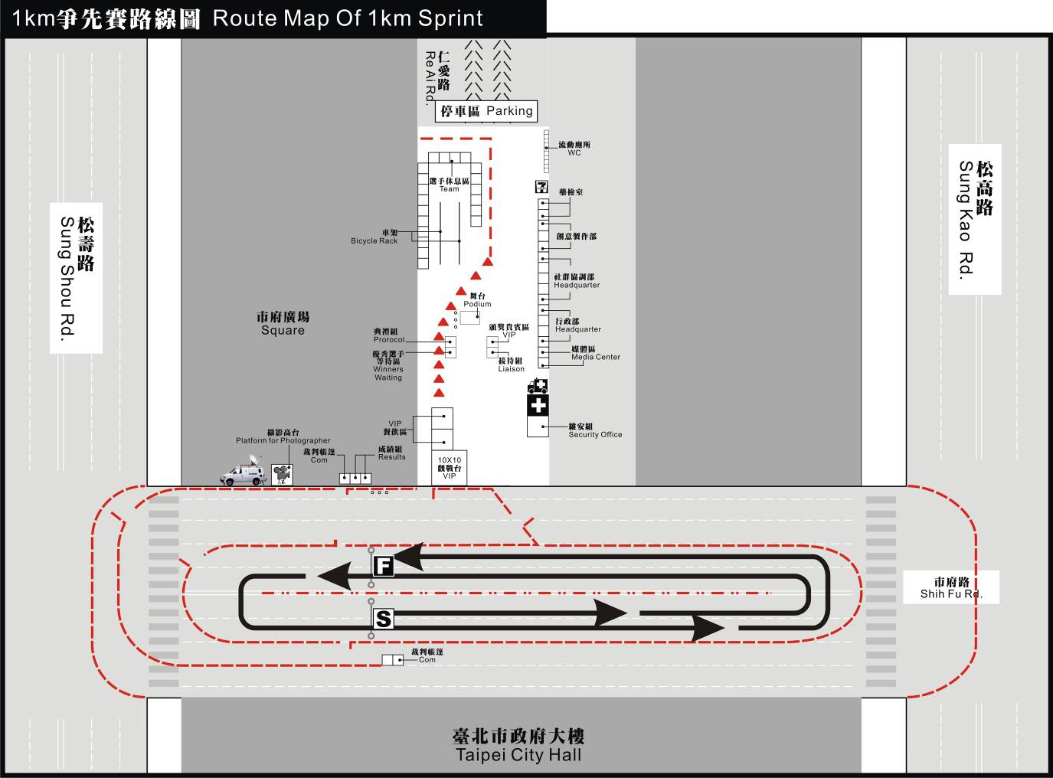
  - Points Race (50km)

2.1 Route Map

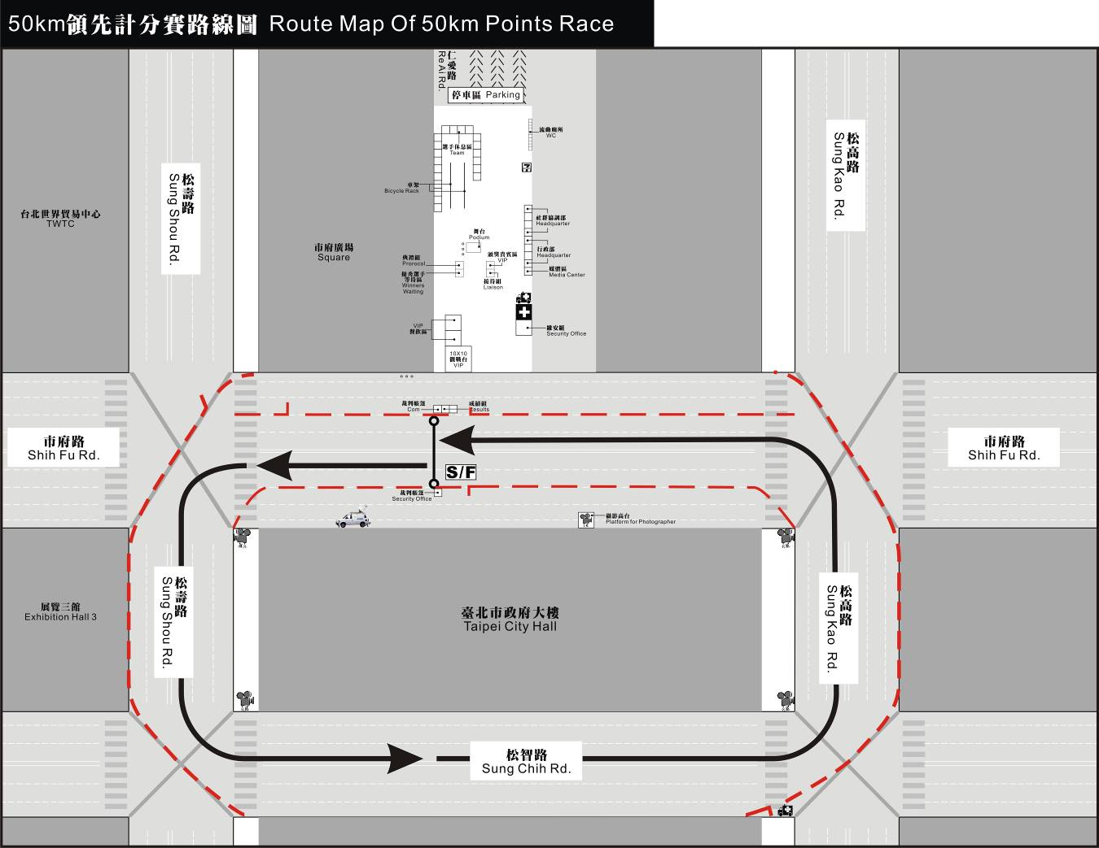

  - Individual Time Trial – Men (34.790km)

3.1 Route Map

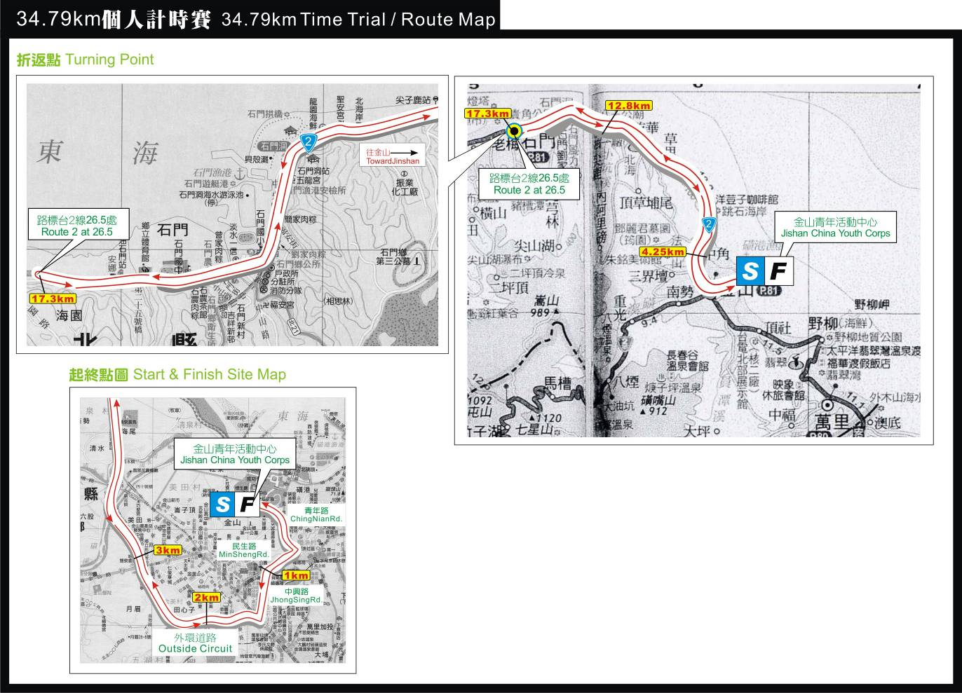

3.2 Start Site Map

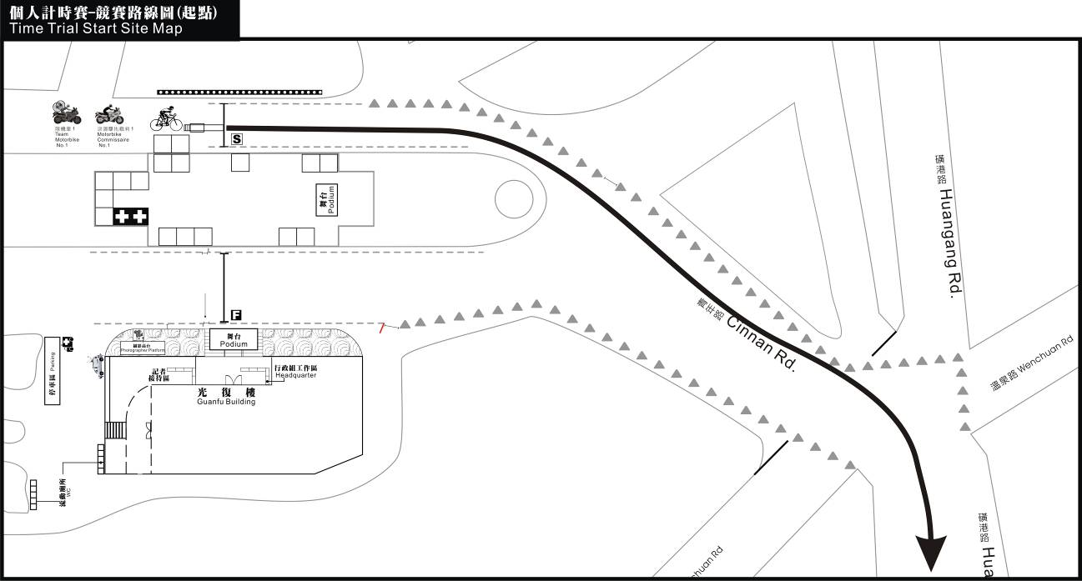

3.3 Finish Site Map

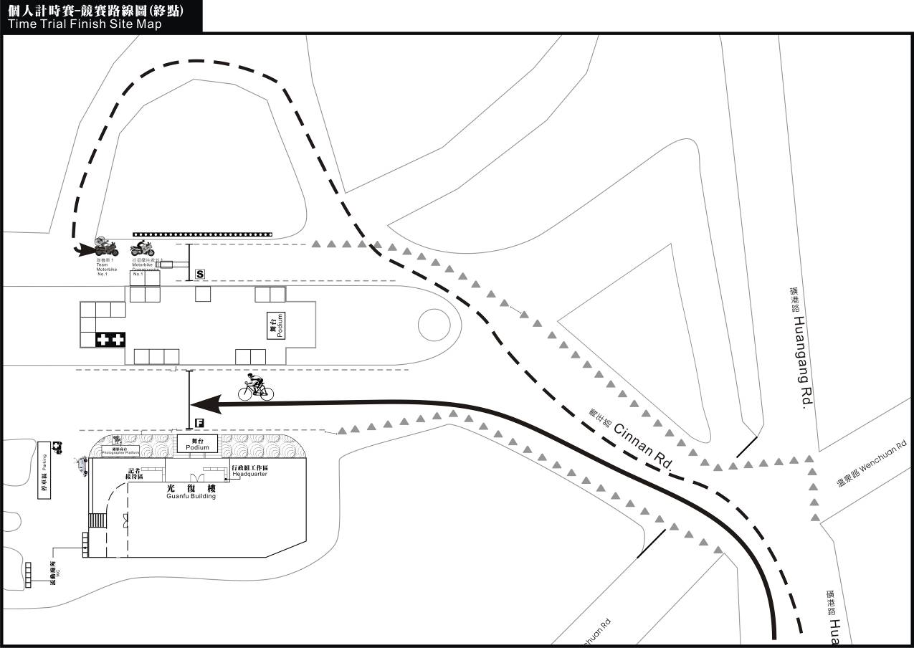

3.4 Profile

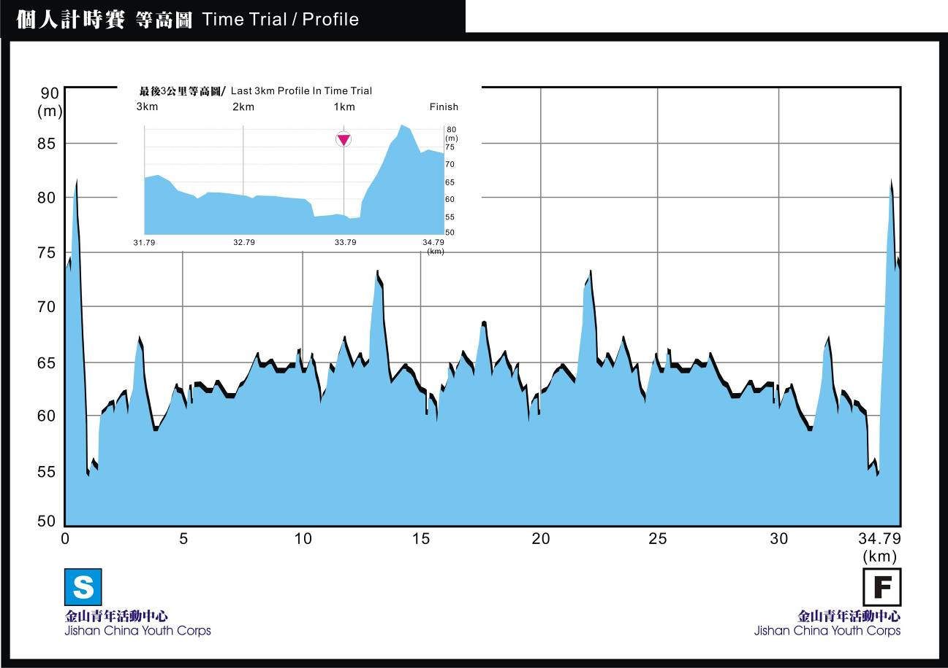

3.5 Estimated Time Schedule
Event：Individual Time Trial |  |  |  |  | Start / Finish：Jinshan Youth Activity Center
Date：8th September |  |  |  |  | Estimated Time of Fast Schedule：10:54
Start time：10:00am |  |  |  |  | Distance : 34.790km
Distance Covered  (km) | Distance Remaining  (km) | Route | Features | Instruction |  | Description | Estimated time arrival(Group 1)
 |  |  |  |  |  |  | 34 | 36 | 38
0.000 | 34.790 | Chinnian Rd |  | Straight on |  | China Youth Corps | 10:00:00 | 10:00:00 | 10:00:00
0.180 | 34.610 | Huanggang Rd | Junction | Turn right |  | Gate | 10:00:19 | 10:00:18 | 10:00:17
0.470 | 34.320 | Huanggang Rd | Fork | Keep right |  |  | 10:00:50 | 10:00:47 | 10:00:45
0.790 | 34.000 | Chungshing Rd | T-junction | Turn left |  | Parking Lot | 10:01:24 | 10:01:19 | 10:01:15
1.160 | 33.630 | Route 2 | Junction | Straight on |  | Traffic Light | 10:02:03 | 10:01:56 | 10:01:50
2.000 | 32.790 | Route 2 |  | Straight on |  | Tire Shop | 10:03:32 | 10:03:20 | 10:03:09
3.000 | 31.790 | Route 2 |  | Straight on |  | Bridge | 10:05:18 | 10:05:00 | 10:04:44
4.000 | 30.790 | Route 2 | Junction | Straight on |  | Chinshuei Station | 10:07:04 | 10:06:40 | 10:06:19
5.000 | 29.790 | Route 2 |  | Straight on |  | nuclear power plant | 10:08:49 | 10:08:20 | 10:07:54
9.800 | 24.990 | Route 2 |  | Straight on |  | Route 2, 34km | 10:17:18 | 10:16:20 | 10:15:28
12.800 | 21.990 | Route 2 |  | Straight on |  | Route 2, 31km | 10:22:35 | 10:21:20 | 10:20:13
15.000 | 19.790 | Route 2 |  | Straight on |  | Route 2, 29km | 10:26:28 | 10:25:00 | 10:23:41
17.340 | 17.450 | Route 2 |  | U Turn |  | Route 2, 26.5km | 10:30:36 | 10:28:54 | 10:27:23
25.840 | 8.950 | Route 2 |  | Straight on |  | Route 2, 35km | 10:45:36 | 10:43:04 | 10:40:48
30.540 | 4.250 | Route 2 | T-junction | Straight on |  | Fakusan | 10:53:54 | 10:50:54 | 10:48:13
32.840 | 1.950 | Route 2 | T-junction | Straight on |  | Route 2, 42km | 10:57:57 | 10:54:44 | 10:51:51
33.540 | 1.250 | Chungshing Rd | Junction | Keep left |  | Chungshin Rd | 10:59:11 | 10:55:54 | 10:52:57
33.940 | 0.850 | Minsheng Rd | T-junction | Turn right |  | Parking Lot | 10:59:54 | 10:56:34 | 10:53:35
33.990 | 0.800 | Huanggang Rd | Fork | Keep left |  | Keep Huanggang Rd | 10:59:59 | 10:56:39 | 10:53:40
34.540 | 0.250 | Chinnian Rd | Junction | Turn left |  | Gate | 11:00:57 | 10:57:34 | 10:54:32
34.690 | 0.100 | Chinnian Rd | Fork | Keep left |  | Fountain | 11:01:13 | 10:57:49 | 10:54:46
34.790 | 0.000 | Chinnian Rd |  | FINISH |  | China Youth Corps | 11:01:24 | 10:57:59 | 10:54:56

3.6 Motorcade

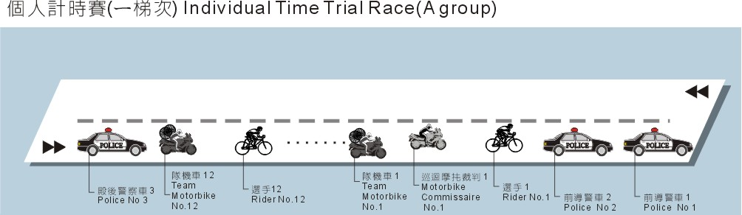
  - Individual Road Race-Men (93.120km)

4.1 Route Map

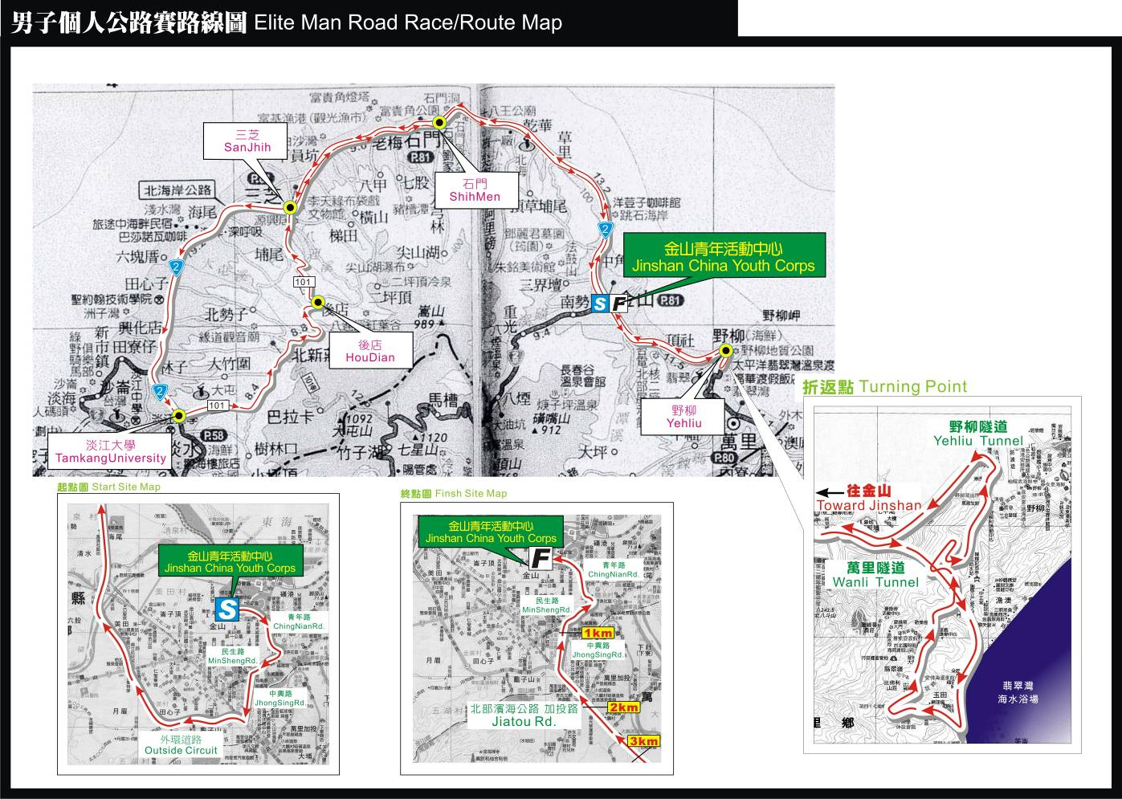

4.2 Start Site Map

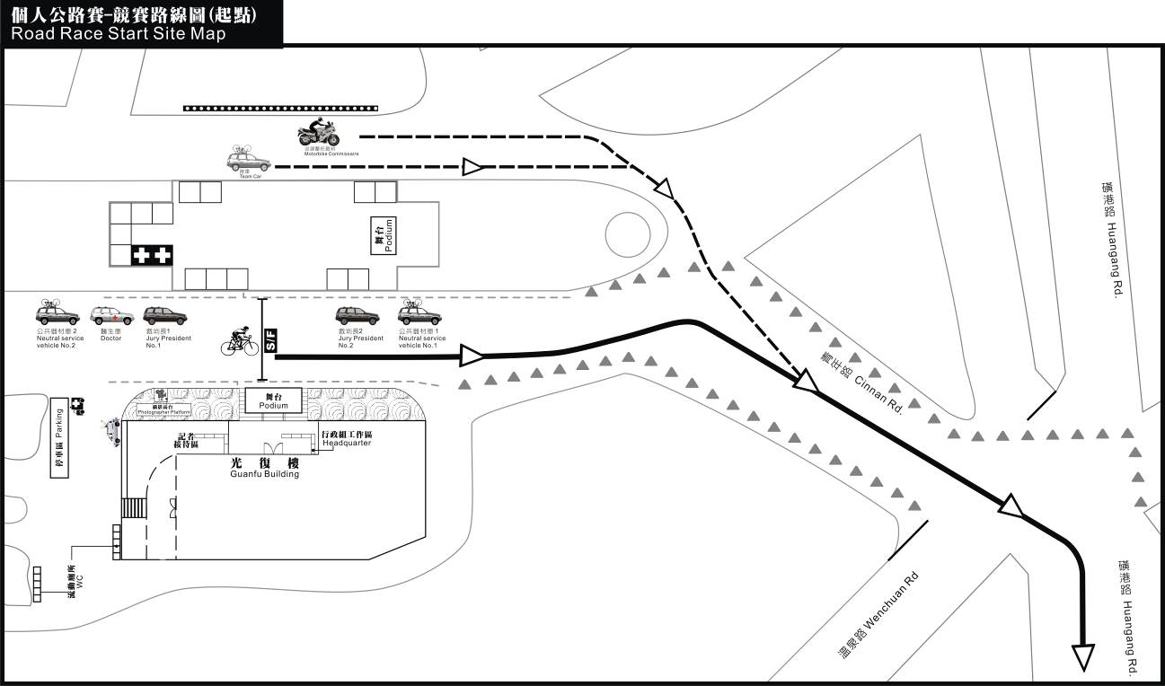

4.3 Finish Site Map

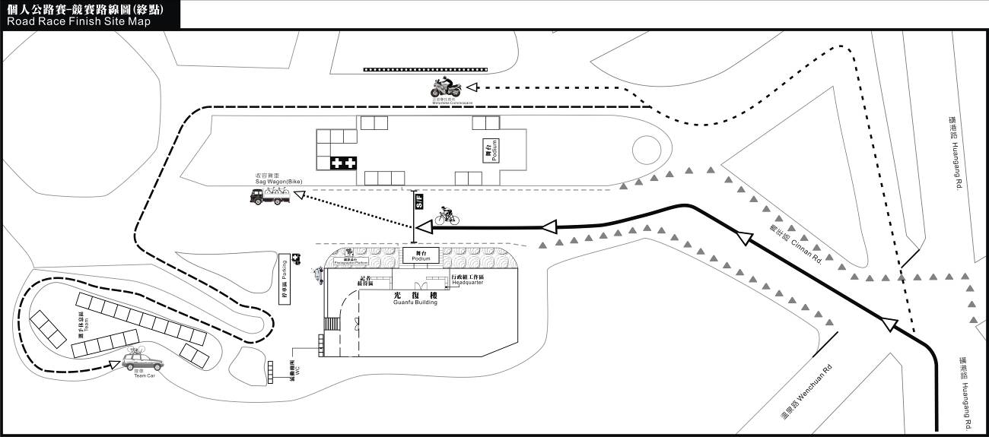

4.4 Profile

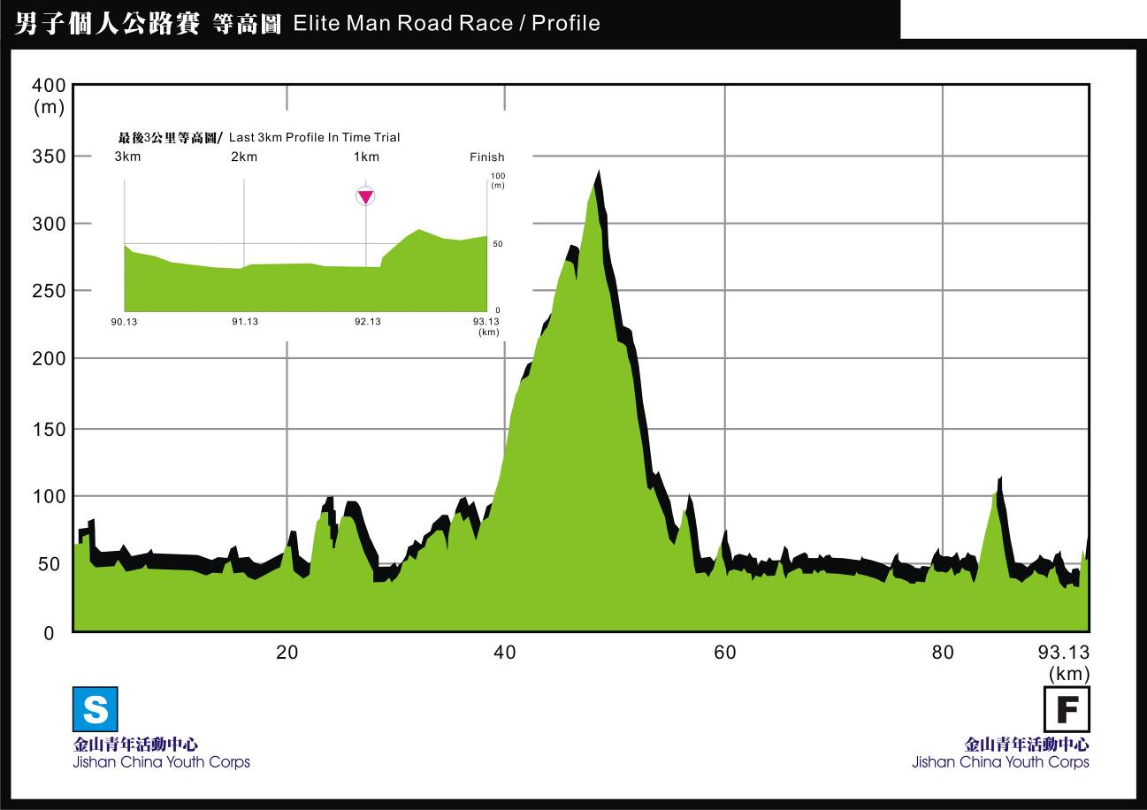

4.5 Estimated Time Schedule
Event：Men Individual Road Race |  |  |  |  | Start / Finish：Jinshan Youth Activity Center
Date：10th September |  |  |  |  | Estimated Time of Fast Schedule：12:13
Start time：10:00am |  |  |  |  | Distance : 93.120km
Distance Covered  (km) | Distance Remaining  (km) | Route | Features | Instruction |  | Description | Estimated time arrival
 |  |  |  |  |  |  | 38 | 40 | 42
0.000 | 93.120 | Chinnian Rd |  | Straight on |  | China Youth Corps | 10:00:00 | 10:00:00 | 10:00:00
0.160 | 92.960 | Huanggang Rd | T-junction | Turn right |  | Gate | 10:00:15 | 10:00:14 | 10:00:14
0.800 | 92.320 | Chungshing Rd | Fork | Turn left |  | Parking Lot | 10:01:16 | 10:01:12 | 10:01:09
1.170 | 91.950 | Route 2 | Junction | Straight on |  | Chungshan Rd | 10:01:51 | 10:01:45 | 10:01:40
7.360 | 85.760 | Route 2 |  | Straight on |  | Coffee shop | 10:11:37 | 10:11:02 | 10:10:31
12.830 | 80.290 | Route 2 |  | Straight on |  | Route 2,31km | 10:20:15 | 10:19:15 | 10:18:20
15.550 | 77.570 | Route 2 | Fork | Turn right |  | Shiman school | 10:24:33 | 10:23:20 | 10:22:13
18.820 | 74.300 | Route 2 |  | Straight on |  | Route 2,25km | 10:29:43 | 10:28:14 | 10:26:53
23.700 | 69.420 | Route 2 |  | Keep Right |  | Route 2,20km | 10:37:25 | 10:35:33 | 10:33:51
24.530 | 68.590 | Route 2 | Forks | Keep Right |  | 7-11(left side) | 10:38:44 | 10:36:48 | 10:35:03
28.800 | 64.320 | Route 2 |  | Straight on |  | Route 2,15km | 10:45:28 | 10:43:12 | 10:41:09
30.300 | 62.820 | Route 2 | Fork | Turn right |  | Tunsan School | 10:47:51 | 10:45:27 | 10:43:17
34.800 | 58.320 | Route 2 | Fork | Straight on |  | Route 2,9km | 10:54:57 | 10:52:12 | 10:49:43
35.000 | 58.120 | Route 2 | Fork | Turn left |  | 7-11 | 10:55:16 | 10:52:30 | 10:50:00
36.700 | 56.420 | Route 2 |  | Straight on |  | Route 2, 7km | 10:57:57 | 10:55:03 | 10:52:26
37.250 | 55.870 | Route 101 | Junction | Turn left |  | Traffic light | 10:58:49 | 10:55:52 | 10:53:13
39.800 | 53.320 | Route 101 |  | Straight on |  | Route 101,13km | 11:02:51 | 10:59:42 | 10:56:51
40.400 | 52.720 | Route 101 | Fork | Keep left |  |  | 11:03:47 | 11:00:36 | 10:57:43
43.700 | 49.420 | Route 101 |  | Straight on |  | Route 101,9km | 11:09:00 | 11:05:33 | 11:02:26
43.960 | 49.160 | Route 101 | Fork | Turn left |  | Hsinhua Police office | 11:09:25 | 11:05:56 | 11:02:48
44.700 | 48.420 | Route 101 |  | Straight on |  | Route 101,8km | 11:10:35 | 11:07:03 | 11:03:51
46.500 | 46.620 | Route 101 | Fork | Straight on |  | Huaien | 11:13:25 | 11:09:45 | 11:06:26
51.600 | 41.520 | Route 101 |  | Straight on |  | Route 101,1km | 11:21:28 | 11:17:24 | 11:13:43
52.000 | 41.120 | 2 Sec,.Chungchen Rd | Junction | Turn right |  | Parking Lot | 11:22:06 | 11:18:00 | 11:14:17
52.200 | 40.920 | 1 Sec,.Chungchen Rd | T-junction | Turn left |  | 1st Sec., Chungchen Rd | 11:22:25 | 11:18:18 | 11:14:34
52.700 | 40.420 | Route 101 | T-junction | Turn right |  | Post office | 11:23:13 | 11:19:03 | 11:15:17
53.000 | 40.120 | Route 2 | Fork | Straight on |  | Route 2,20km | 11:23:41 | 11:19:30 | 11:15:43
61.200 | 31.920 | Route 2 | Fork | Turn left |  | Shihman School | 11:36:38 | 11:31:48 | 11:27:26
63.900 | 29.220 | Route 2 |  | Straight on |  | Route 2,31km | 11:40:54 | 11:35:51 | 11:31:17
72.900 | 20.220 | Route 2 |  | Straight on |  | Route 2,40km | 11:55:06 | 11:49:21 | 11:44:09
75.700 | 17.420 | Route 2 | Junction | Turn right |  | Chungsan Rd | 11:59:32 | 11:53:33 | 11:48:09
77.000 | 16.120 | Route 2 |  | Straight on |  | Route 2,44km | 12:01:35 | 11:55:30 | 11:50:00
78.900 | 14.220 | Route 2 |  | Straight on |  | Route 2, 46km | 12:04:35 | 11:58:21 | 11:52:43
79.700 | 13.420 | Route 2 | Fork | Keep Right |  | Toward Wanli Tunnel | 12:05:51 | 11:59:33 | 11:53:51
80.110 | 13.010 | Route 2 |  | Straight on |  | Wanli Tunnel | 12:06:29 | 12:00:10 | 11:54:27
82.780 | 10.340 |  | Fork | Turn right |  | Howard | 12:10:42 | 12:04:10 | 11:58:15
86.280 | 6.840 |  |  | Straight on |  | Yaliu Tunnel | 12:16:14 | 12:09:25 | 12:03:15
87.880 | 5.240 | Route 2 | Fork | Keep Right |  | Bridge | 12:18:45 | 12:11:49 | 12:05:33
90.580 | 2.540 | Route 2 |  | Straight on |  | Route 2, 44km | 12:23:01 | 12:15:52 | 12:09:24
91.580 | 1.540 | Route 2 |  | Straight on |  | Route 2, 43km | 12:24:36 | 12:17:22 | 12:10:50
91.910 | 1.210 | Chungshing Rd | Forks | Turn right |  |  | 12:25:07 | 12:17:52 | 12:11:18
92.280 | 0.840 | Minsheng Rd | T-junction | Turn right |  | Parking Lot | 12:25:42 | 12:18:25 | 12:11:50
92.880 | 0.240 | Chinnian Rd | T-junction | Turn left |  | Gate | 12:26:39 | 12:19:19 | 12:12:41
93.120 | 0.000 | Chinnian Rd |  | FINISH |  | China Youth Corps | 12:27:02 | 12:19:41 | 12:13:02

4.6 Motorcade

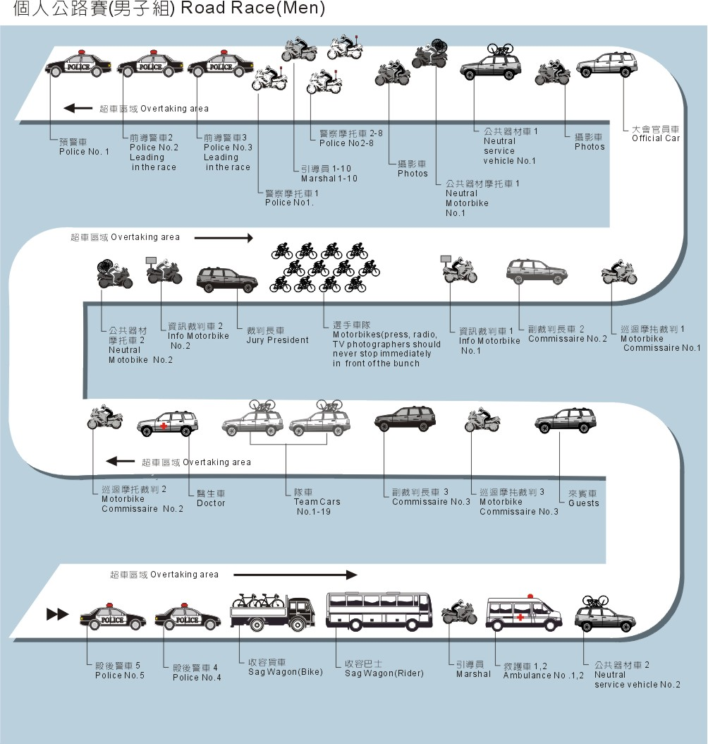

  - Race Signage
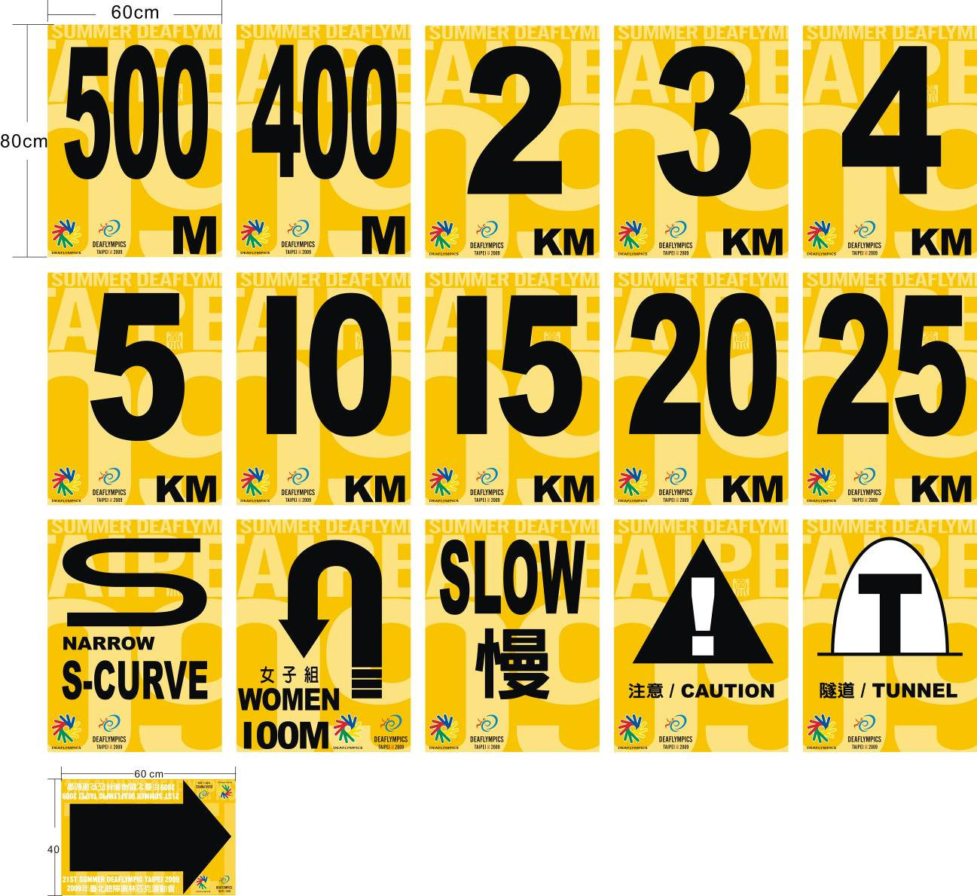
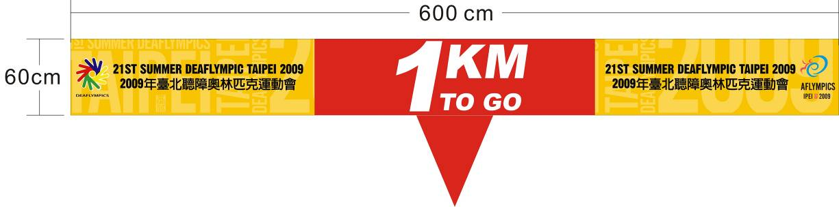

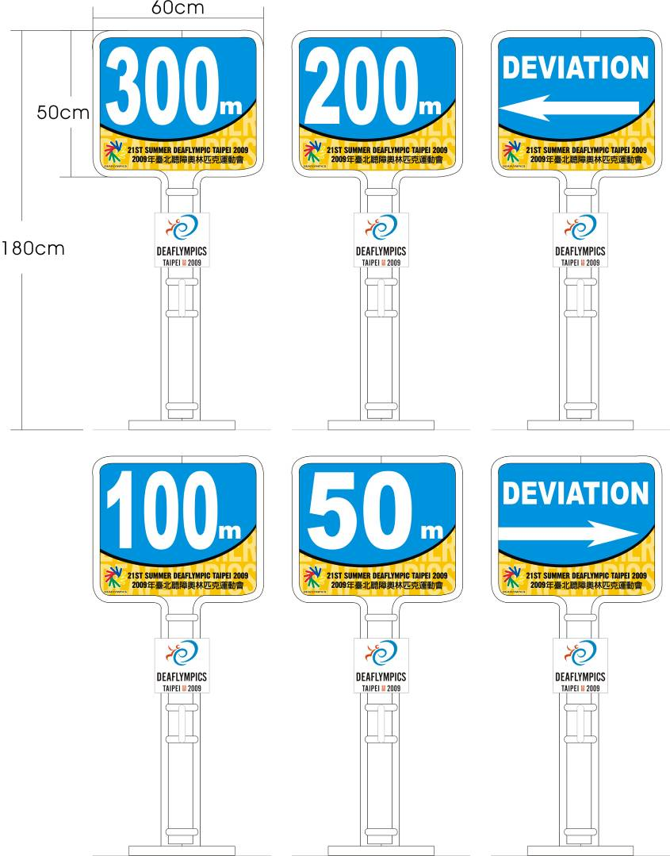


  - Number

6.1 Sample of Body Number

6.1.1 Men

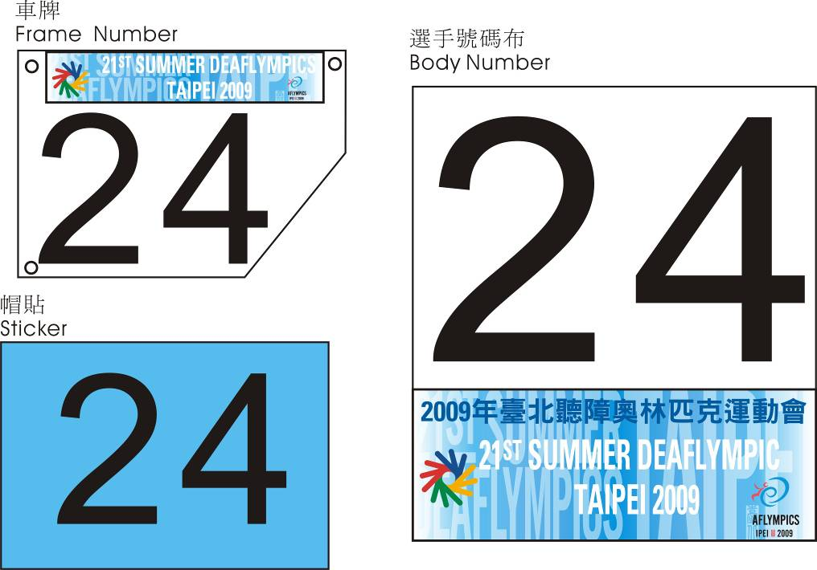

6.2 Position of Body Number
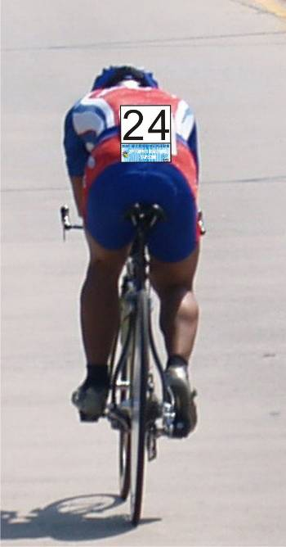 |  | 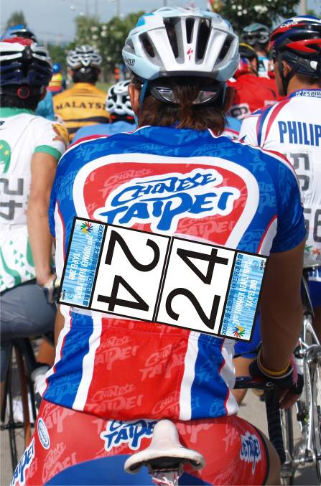
- Only one number is required for the qualification of sprint and the Individual time trial.  - It should be worn as demonstrated in the picture above. |  | - Consists of two numbers to be worn as demonstrated in the picture above.

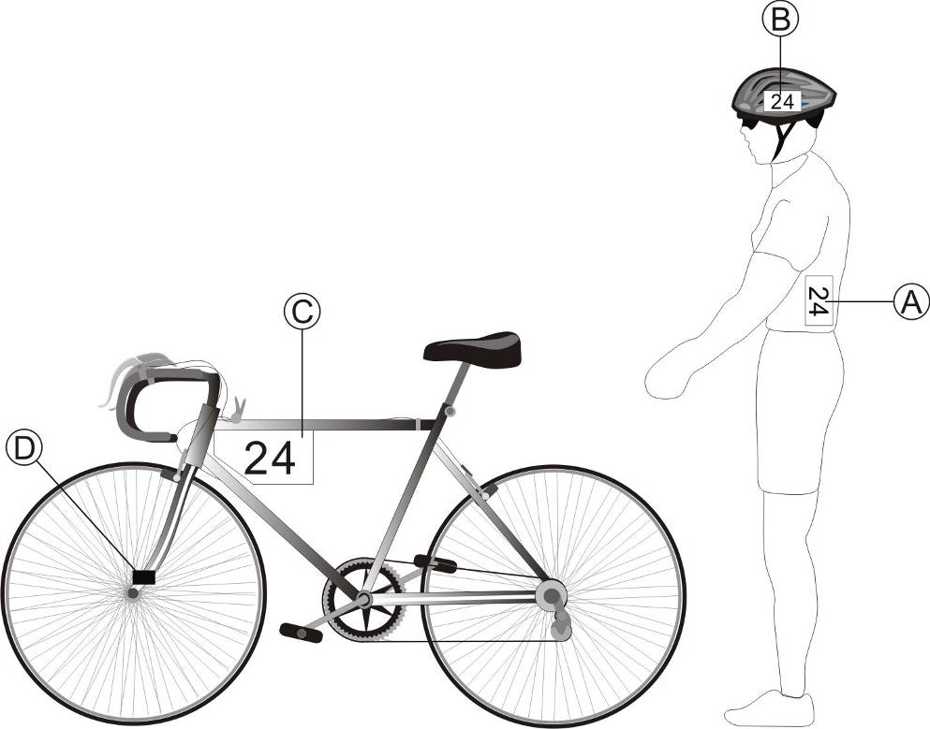
A Body Number
B Sticker
C Frame Number
D Chip
- Location
  - Taipei City Hall Plaza
    - September 6th Sprint
    - September 12th Points Race

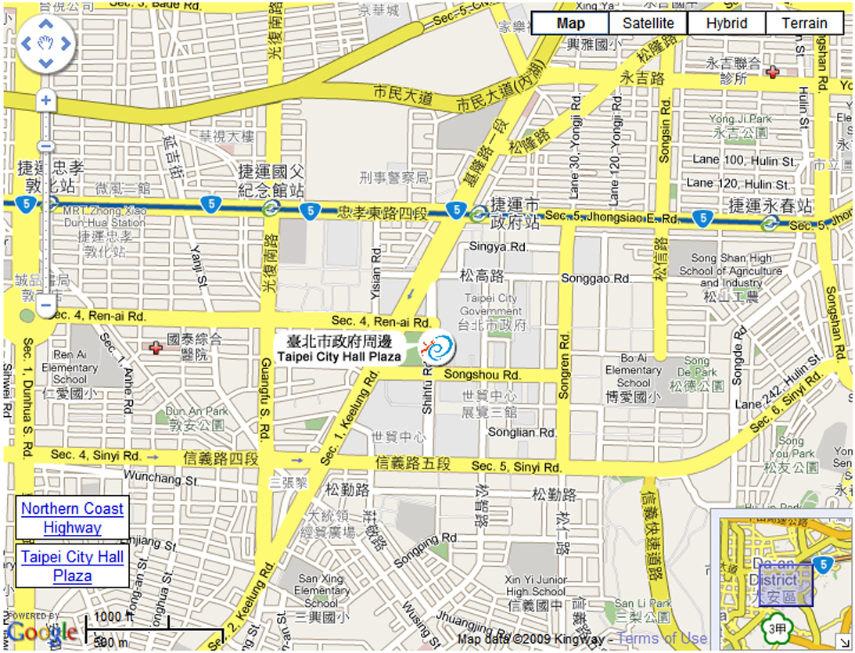
  - Jinshan Youth Activity Center
    - September 8th Individual Time Trial
    - September 10th Individual Road Race

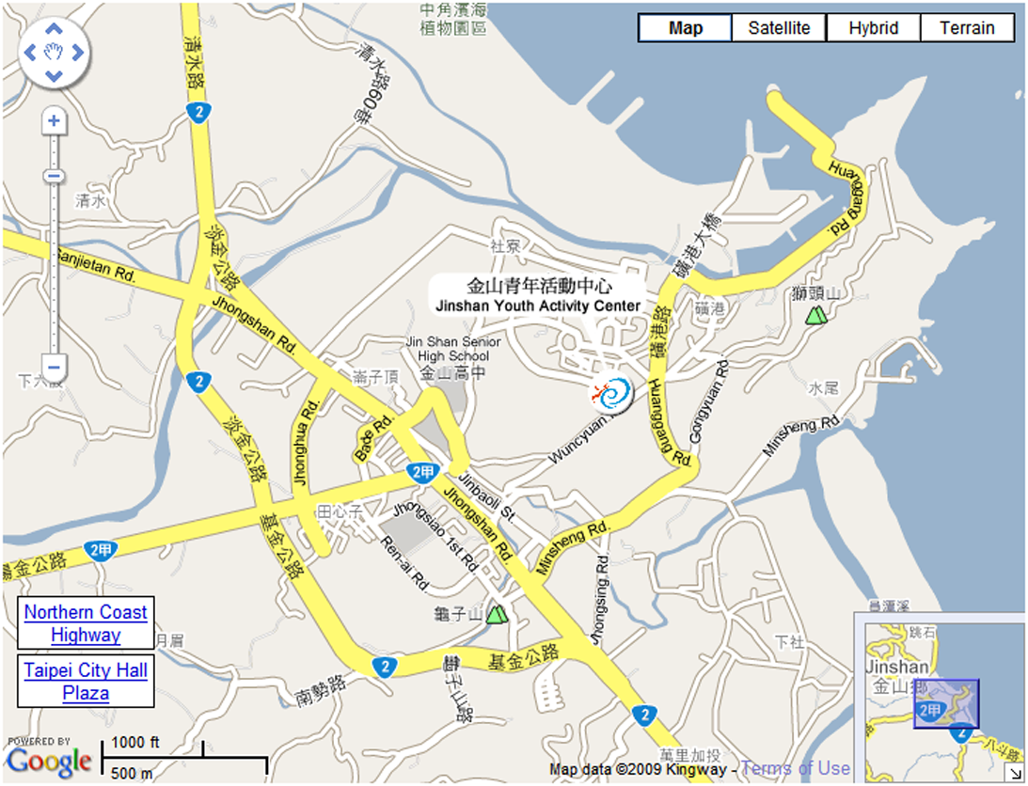
- Inspection Schedule
Date | Time | Event
07/09（Mon） | 10:00-14:00 | Individual Time Trial & Road Race
- Road circuit will not be closed during those periods. All road inspection is done by bus.
- Toilets and team tents will be available at start / finish area
- Competition Schedule
Day | Date | Time | Event | Place
Day One | 04/09（Fri） | 16:00 | Technical Meeting | Room 100A, 2F, Kungcheng Building ,National Taipei University of Education Kungcheng Building
Day Two | 05/09（Sat） |  | Opening Ceremony
Day Three | 06/09（Sun） | 09:00 | 1km Sprint | Taipei City Hall Shihfu Rd
Day Four | 07/09（Mon） |  | Off/ Road Inspection for Road Race and Individual Time Trial
Day Five | 08/09（Tue） | 10:00 | Men-Individual Time Trial （34.790km）  Awarding Ceremony | Jinshan Youth Activity Center
Day Six | 09/09（Wed） |  | Off
Day Seven | 10/09（Thu） | 10:00 | Men-Individual Road Race（93.120km）  Awarding Ceremony | Jinshan Youth Activity Center
Day Eight | 11/09（Fri） |  | Off
Day Nine | 12/09（Sat） | 09:00 | Points Race（50km）  Awarding Ceremony | Taipei City Hall Plaza
- Time Table of Competition
6th September, 2009(Sunday)
Morning | 0900 – 0945 | Men |  | Sprint |  | Qualifying for 200m sprint time trial
 | 1000 – 1007 |  |  |  |  | 1/8 final Heat 1 @ 1 round
 |  | (winners to ¼ final, loser ranked according to 200m time trial result)
 | 1007 – 1014 |  |  |  |  | 1/8 final Heat 2 @ 1 round
 | 1014 – 1021 |  |  |  |  | 1/8 final Heat 3 @ 1 round
 | 1021 – 1030 |  |  |  |  | 1/8 final Heat 4 @ 1 round
 | 1045 – 1055 |  |  |  |  | 1/4 final Heat 1 @ 1 round
 | 1055 – 1105 |  |  |  |  | 1/4 final Heat 2 @ 1 round
 | 1105 – 1115 |  |  |  |  | 1/4 final Heat 3 @ 1 round
 | 1115 – 1125 |  |  |  |  | 1/4 final Heat 4 @ 1 round
 | 1130 – 1135 |  |  |  |  | 5 to 8th placing
 | 1140 – 1148 |  |  |  |  | 1/2 final Heat 1 @ round 1
 | 1148 – 1155 |  |  |  |  | 1/2 final Heat 2 @ round 1
Afternoon | 1200 – 1208 | Men |  | Sprint |  | 1/2 final Heat 1 @ round 2
 | 1208 – 1215 |  |  |  |  | 1/2 final Heat 2 @ round 2
 | 1215 – 1225 |  |  |  |  | If ended in a draw, final again
 | 1230 – 1238 |  |  |  |  | Final 3 and 4 placing round 1
 | 1238 – 1245 |  |  |  |  | final 1 and 2 placing round 1
 | 1255 – 1300 |  |  |  |  | final 3 and 4 placing round 2
 | 1300 – 1305 |  |  |  |  | final 1 and 2 placing round 2
 | 1310 – 1315 |  |  |  |  | If ended in a draw, final again
 | 1330 - |  |  |  |  | Awarding ceremony
8th September, 2009(Tuesday)
Morning | 1000 –1120 | Men |  | Individual Time Trial |  | 34.790km- Group 1
 | 1140 –1300 |  |  |  |  | 34.790km- Group 2
 | 1330 – | Men |  | Individual Time Trial |  | Awarding ceremony
10th September, 2009(Thursday)
Morning | 1000 –1227 | Men |  | Individual Road Race | 93.120km
 | 1245 – | Men |  | Individual Road Race | Awarding ceremony
12th September, 2009(Saturday)
Morning | 0900 – | Men | 50km Points Race |  | final
 | 1030 – | Men | 50km Points Race |  | Awarding ceremony

- Records

- Map
- Games Program Schedule
日期  競賽種類 | ９月
日期  競賽種類 | 1 | 2 | 3 | 4 | 5 | 6 | 7 | 8 | 9 | 10 | 11 | 12 | 13 | 14 | 15
日期  競賽種類 | 周二 | 周三 | 周四 | 周五 | 周六 | 周日 | 周一 | 周二 | 周三 | 周四 | 周五 | 周六 | 周日 | 周一 | 周二
典禮 | A | A |  |  | O |  |  |  |  |  |  |  |  |  | C
ICSD 大會 |  |  | ICSD | ICSD
田徑 |  |  |  | T | T | T | G | G | G | R | G | G | G
馬拉松 |  |  |  |  |  |  |  |  |  |  |  |  |  | G
羽球 |  |  | T | T | T | G | G | G | G | G | G | G | G | G
籃球 |  |  | T | T | T | G | G | G | G | G | G | G | G | G
沙灘排球 |  |  | T | T | T | G | G | G | G | G | G | G | G | G
保齡球 |  |  |  |  | T | T | T | G | G | G | G | R | G | G
自由車 |  |  | T | T | T | G | R | G | R | G | R | G
足球 | T | T | T | G | G | G | G | G | G | G | G | G | G | G | G
手球 |  |  | T | T | T | G | G | G | R | G | R | G
柔道 |  |  |  |  | T | T | T | G | G | G
空手道 |  |  |  | T | T | T | G | G
定向越野 |  |  |  |  | T | T | T | G | G | R | G | R | G
射擊 |  |  | T | T | T | G | G | G | G | G | G | G | G | G
游泳 |  |  |  | T | T | T | G | G | G | R | G | G | G
桌球 |  |  | T | T | T | G | G | G | G | G | G | G | G | G
跆拳道 |  |  | T | T | T | G | G | G | G
網球 |  |  | T | T | T | G | G | G | G | G | G | G | G
排球 |  |  | T | T | T | G | G | G | G | G | G | G | G
水球 |  |  | T | T | T | G | G | G | G | G | R | G | G
角力 |  |  |  | T | T | T | G | G | R | G | G

備註：「A」-抵臺 「O」-開幕典禮 「C」-閑幕典禮 「D」-離臺
「T」-練習 「G」-比賽 「R」-Ｏ 休賽
- Contact Information
FOUNDATION OF 21TH SUMMER DEAFLYMPICS ORGANIZING COMMITTEE
3-4f., Taipei Arena, No.2,Sec.4,Nanjing E. Rd.,
Songshan District, Taipei City 10553, Taiwan(R.O.C.)
TEL：+886-2-2577-2009
FAX：+886-2-2577-2851, +886-2-2577-2852
http://www.2009deaflympics.org

CHINESE TAIPEI SPORTS ASSOCIATION OF THE DEAF
Rm. 214, 2F., No.55, Changji St.,
Datong District, Taipei City 10363, Taiwan (R.O.C.)
TEL：+886-2-2597-4352
FAX：+886-2-2597-4353, +886-2-2597-0472
http://www.deafsports.org.tw

CHINESE TAIPEI CYCLING ASSOCIATION
Left Side of Velodrome, NO.160, Chinan Rd.,
Kaohsiung, Taiwan (R.O.C.)
TEL：+886-7-355-6978
FAX：+886-7-355-6962
http://www.cycling.org.tw/

